**SWD Project Report**

**Software Design Document**

– Hanoi, August 2023 –

# **I. Record of Changes**

| Date | A* M, D | In charge | Change Description |
| --- | --- | --- | --- |
| 24/10/2023 | A | Nam | Package Diagram |
| 24/10/2023 | A | Nam | System Design |
| 24/10/2023 | A | Nam | Class Specifications: User |
| 24/10/2023 | A | Việt Anh | Class Specifications: Class |
| 24/10/2023 | A | Bình | Database Design |
|  |  |  |  |
|  |  |  |  |
|  |  |  |  |

*A - Added M - Modified D - Deleted

# **II. Software Design Document**

## **1. System Design**

### **1.1 System Architecture**

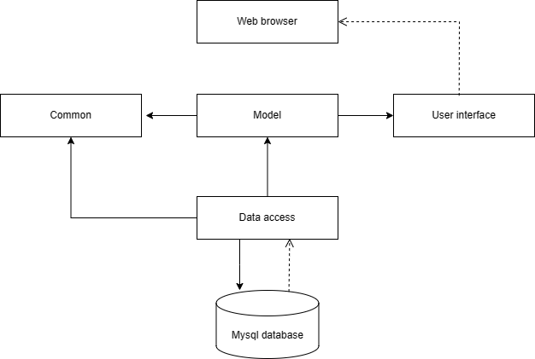

| **No** | **Component** | **Description** |
| --- | --- | --- |
| *01* | *User Interface* | *User Interface component is responsible for the presentation layer of the software application. It handles the visual elements that users interact with and the rendering of data to the user interface. This includes tasks like displaying forms, templates, and user interface components to provide a user-friendly experience.* |
| *02* | *Application Logic* | *Application Logic component contains the core logic and business rules of the software application. It manages the application's data, processes, and overall functionality. This component is responsible for executing operations like data processing, business rules, and application workflows.* |
| *03* | *Data Access* | *Data Access component, often referred to as the DAO (Data Access Object) layer, facilitates interactions with the database. It is responsible for retrieving, storing, and manipulating data in the database, ensuring data integrity and efficient data access.* |
| *04* | *Model* | *Model component defines the data structures and entities used within the application. It represents the application's data and its relationships, as well as encapsulating the business logic that operates on the data.* |
| *05* | *Common Utilities* | *Common Utilities component houses shared code and utilities that are used throughout the application. These utilities can include functions, libraries, or modules that promote code reusability and maintainability.* |
| *06* | *Web Services* | *Web Services" component handles web-related functionalities, including routing, managing HTTP requests and responses, and orchestrating interactions with external web services or APIs.* |

### **1.2 Package Diagram**

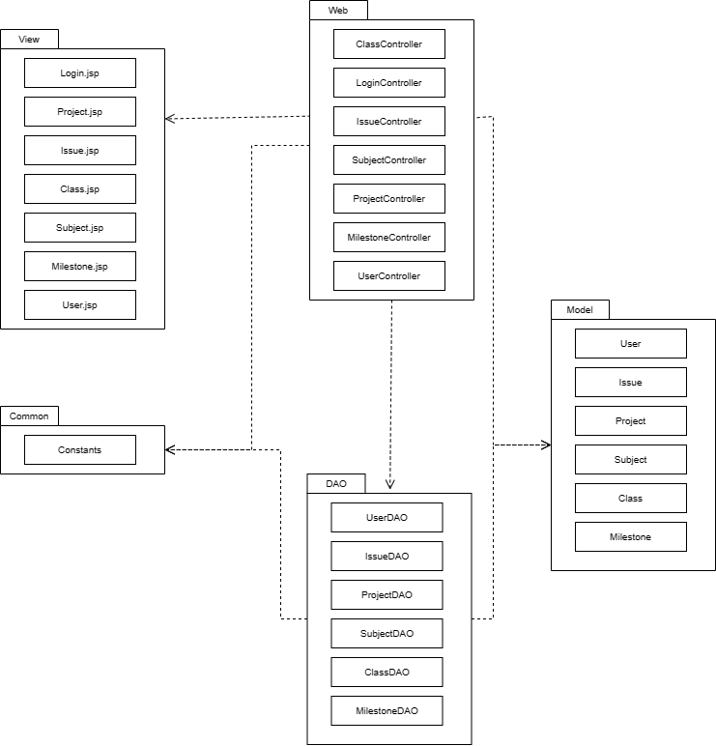

***Package descriptions***

| **No** | **Package** | **Description** |
| --- | --- | --- |
| *01* | *view* | *View package is designed to handle the user interface components and presentation logic of the software application. It encompasses the elements responsible for rendering information to the user, such as forms, templates, and user interface components* |
| *02* | *web* | *Web package focuses on handling web-related functionalities within the software application. It typically includes components for routing, handling HTTP requests and responses, and managing web server interactions.* |
| *03* | *common* | *Common package appears to be listed without a specific description. Common packages often contain reusable code and utilities that are shared across different parts of the software application to promote code reusability and maintainability.* |
| *04* | *dao* | *Dao package is typically used for Data Access Object (DAO) implementations. DAOs are responsible for managing interactions with the database, encapsulating the logic for data retrieval, storage, and manipulation* |
| *05* | *model* | *Model package is responsible for defining and managing the data structures and business logic of the application. It often includes data models, business entities, and the core application logic for data manipulation.* |

### **1.3 Database Design**

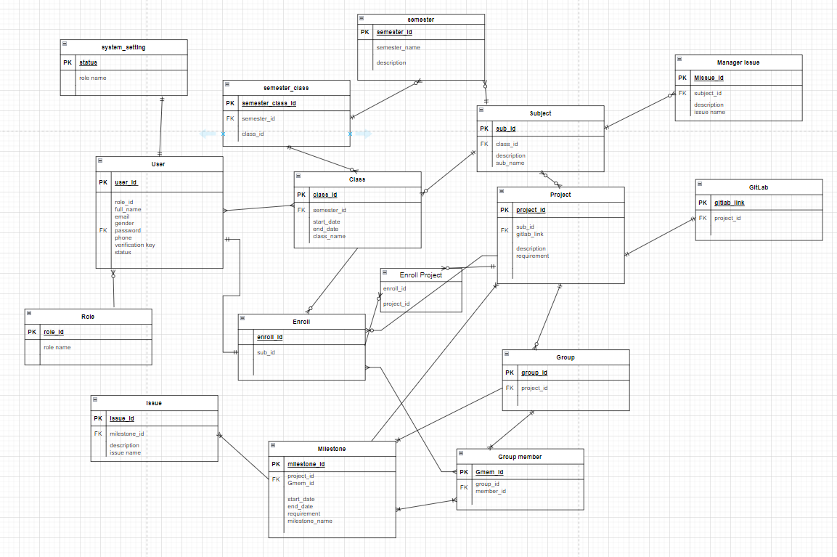

#### **1.3.1 System_setting**

| **No** | **Field** | **PK** | **FK** | **UN** | **NN** | **Description** |
| --- | --- | --- | --- | --- | --- | --- |
| *01* | ***status*** | *✔* |  |  | *✔* | *Status of user account is active or deactive* |
| *02* | *domain_email* |  |  |  | *✔* | *User for login system* |
| *..* |  |  |  |  |  |  |

#### **1.3.2 User**

| **No** | **Field** | **PK** | **FK** | **UN** | **NN** | **Description** |
| --- | --- | --- | --- | --- | --- | --- |
| *01* | ***user_id*** | *✔* |  | *✔* | *✔* | *ID number of user* |
| *02* | *role_id* |  | *✔* |  | *✔* | *Role of user in system* |
| *03* | *full_name* |  |  |  | *✔* | *Full name of user* |
| *04* | *email* |  |  | *✔* | *✔* | *Personal user email* |
| *05* | *gender* |  |  |  | *✔* | *Gender of user* |
| *06* | *password* |  |  |  | *✔* | *Password of system account* |
| *07* | *phone* |  |  | *✔* | *✔* | *Phone number of user* |
| *08* | *verification key* |  |  |  | *✔* | *OTP user for login, forgot password* |
| *09* | *status* |  | *✔* |  | *✔* | *Status of user account is active or deactive* |
| *10* | *domain_email* |  |  | *✔* | *✔* | *Email use for login system* |

#### **1.3.3 Role**

#### 

| *01* | ***role_id*** | *✔* |  | *✔* | *✔* | *Role id of user* |
| --- | --- | --- | --- | --- | --- | --- |
| *02* | *role name* |  |  |  | *✔* | *Name of role of user* |
| *..* |  |  |  |  |  |  |

#### **1.3.4 Semester**

| **No** | **Field** | **PK** | **FK** | **UN** | **NN** | **Description** |
| --- | --- | --- | --- | --- | --- | --- |
| *01* | ***semester_id*** | *✔* |  | *✔* | *✔* | *ID of semester* |
| *02* | *semester_name* |  |  | *✔* | *✔* | *Name of semester* |

#### **1.3.5 Subject**

| **No** | **Field** | **PK** | **FK** | **UN** | **NN** | **Description** |
| --- | --- | --- | --- | --- | --- | --- |
| *01* | ***sub_id*** | *✔* |  | *✔* | *✔* | *ID of subject* |
| *02* | *class_id* |  | *✔* | *✔* | *✔* | *ID of class* |
| *03* | *description* |  |  | *✔* | *✔* | *description of subject* |
| *04* | *sub_name* |  |  | *✔* | *✔* | *subject name* |
| *05* | *semester_id* |  |  | *✔* | *✔* | *ID of semester* |

#### **1.3.6 Project**

| **No** | **Field** | **PK** | **FK** | **UN** | **NN** | **Description** |
| --- | --- | --- | --- | --- | --- | --- |
| *01* | ***project_id*** | *✔* |  | *✔* | *✔* | *ID of project* |
| *02* | *sub_id* |  | *✔* | *✔* | *✔* | *ID of subject* |
| *03* | *gitlab_link* |  |  | *✔* | *✔* | *link of Gitlab* |
| *04* | *description* |  |  | *✔* | *✔* | *description of project* |
| *05* | *requirement* |  |  | *✔* | *✔* | *requirement of project* |

#### **1.3.7 Manager Issue**

| **No** | **Field** | **PK** | **FK** | **UN** | **NN** | **Description** |
| --- | --- | --- | --- | --- | --- | --- |
| *01* | ***Issue_id*** | *✔* |  | *✔* | *✔* | *ID of issue* |
| *02* | *sub_id* |  | *✔* | *✔* | *✔* | *ID of subject* |
| *03* | *description* |  |  | *✔* | *✔* | *description of issue* |
| *04* | *issue name* |  |  | *✔* | *✔* | *name of issue* |

#### **1.3.8 Gitlab**

| **No** | **Field** | **PK** | **FK** | **UN** | **NN** | **Description** |
| --- | --- | --- | --- | --- | --- | --- |
| *01* | ***gitlab_link*** | *✔* |  | *✔* | *✔* | *Link of Gitlab* |
| *02* | *project_id* |  | *✔* | *✔* | *✔* | *ID of project* |

#### **1.3.9 Enroll**

| **No** | **Field** | **PK** | **FK** | **UN** | **NN** | **Description** |
| --- | --- | --- | --- | --- | --- | --- |
| *01* | ***enroll_id*** | *✔* |  | *✔* | *✔* | *ID to identify when user enroll* |
| *02* | *class_id* |  | *✔* | *✔* | *✔* | *ID of class* |

#### **1.3.10 Enroll Project**

| **No** | **Field** | **PK** | **FK** | **UN** | **NN** | **Description** |
| --- | --- | --- | --- | --- | --- | --- |
| *01* | ***enroll_id*** | *✔* |  | *✔* | *✔* | *ID to identify when user enroll* |
| *02* | *project_id* |  | *✔* | *✔* | *✔* | *ID of project* |

#### **1.3.11 Group**

**.**

| **No** | **Field** | **PK** | **FK** | **UN** | **NN** | **Description** |
| --- | --- | --- | --- | --- | --- | --- |
| *01* | ***group_id*** | *✔* |  | *✔* | *✔* | *ID of group* |
| *02* | *project_id* |  | *✔* | *✔* | *✔* | *ID of project* |

#### **1.3.12 Group member**

| **No** | **Field** | **PK** | **FK** | **UN** | **NN** | **Description** |
| --- | --- | --- | --- | --- | --- | --- |
| *01* | ***Gmem_id*** | *✔* |  | *✔* | *✔* | *ID of group member* |
| *02* | *group_id* |  | *✔* | *✔* | *✔* | *ID of group* |
| *03* | *member_id* |  |  | *✔* | *✔* | *ID of member* |

#### **1.3.13 Milestone**

| **No** | **Field** | **PK** | **FK** | **UN** | **NN** | **Description** |
| --- | --- | --- | --- | --- | --- | --- |
| *01* | ***milestone_id*** | *✔* |  | *✔* | *✔* | *ID of group* ***Milestone*** |
| *02* | *project_id* |  | *✔* | *✔* | *✔* | *ID of project* |
| *03* | *Gmem_id* |  |  | *✔* | *✔* | *ID of group member* |
| *04* | *start_date* |  |  | *✔* | *✔* | *start date* |
| *05* | *end_date* |  |  | *✔* | *✔* | *end date* |
| *06* | *requirement* |  |  | *✔* | *✔* | *milestones requirement* |
| *07* | *milestone_name* |  |  | *✔* | *✔* | *name of milestone* |

#### **1.3.14 Issue**

| **No** | **Field** | **PK** | **FK** | **UN** | **NN** | **Description** |
| --- | --- | --- | --- | --- | --- | --- |
| *01* | ***Issue_id*** | *✔* |  | *✔* | *✔* | *ID of issue* |
| *02* | *milestone_id* |  | *✔* | *✔* | *✔* | *ID of milestone* |
| *03* | *description* |  |  | *✔* | *✔* | *description of issue* |
| *04* | *issue name* |  |  | *✔* | *✔* | *name of issue* |

#### **1.3.15 Semester class**

| **No** | **Field** | **PK** | **FK** | **UN** | **NN** | **Description** |
| --- | --- | --- | --- | --- | --- | --- |
| *01* | ***semester_class_id*** | *✔* |  | *✔* | *✔* | *id of semester of class* |
| *02* | *semester_id* |  | *✔* | *✔* | *✔* | *ID of semester* |
| *03* | *class_id* |  | *✔* | *✔* | *✔* | *id of class* |

## **3. Detailed Design**

### **3.1. Register account**

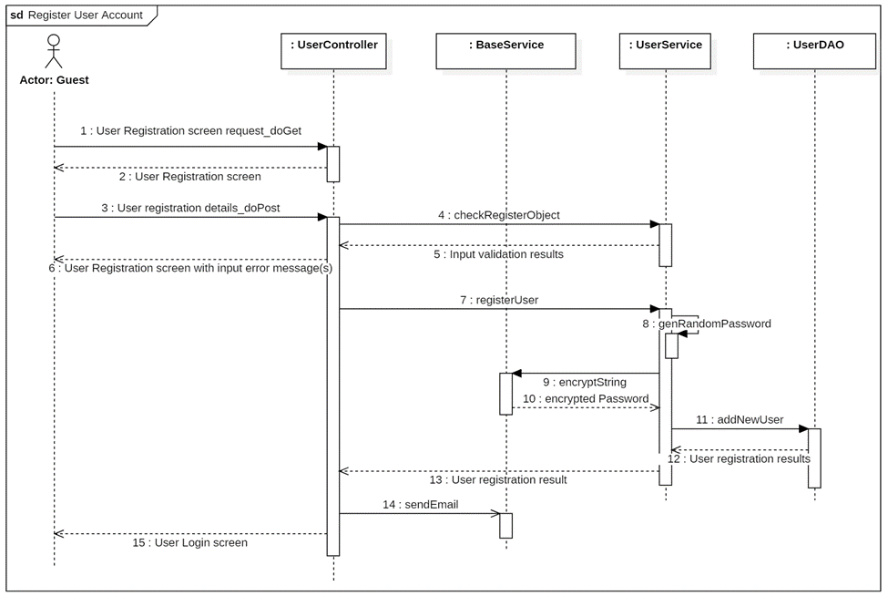

### **3.2 <Subject>**

#### **3.2.1 Subject list**

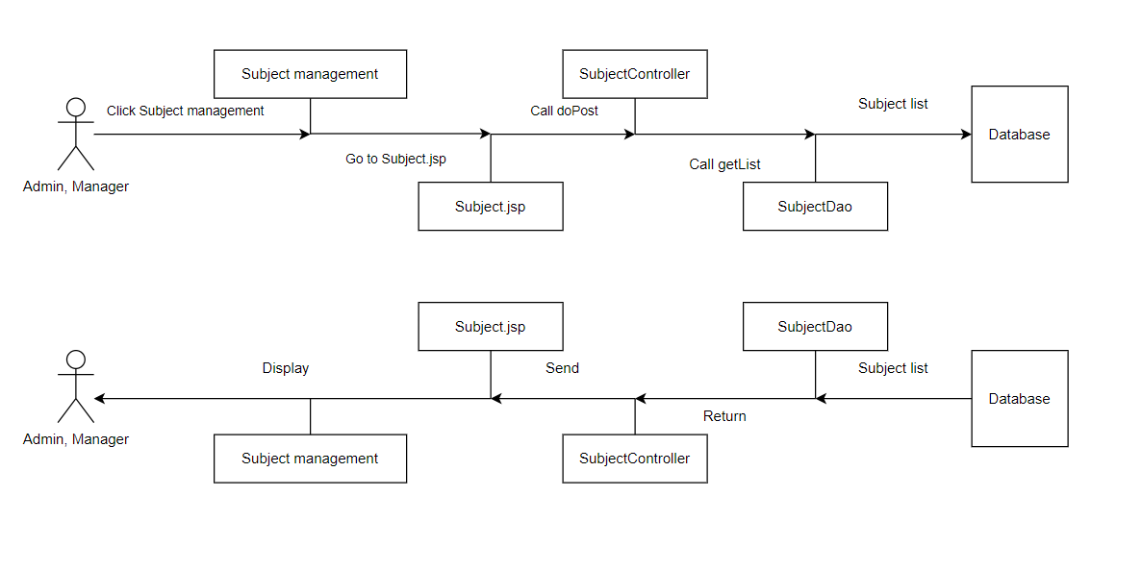

#### **3.2.1 Subject detail**

## **4. Class Specifications**

### **4.1 Project Management**

#### **4.1.1 User**

| **No** | **Name** | **Description** |
| --- | --- | --- |
| ***Attributes*** | | |
| 01 | userID | Visibility: private, Type: int, Purpose: Unique identifier for the user. |
| 02 | fullName | Visibility: private, Type: String, Purpose: User's full name. |
| 03 | email | Visibility: private, Type: String, Purpose: User's email address. |
| 04 | gender | Visibility: private, Type: Boolean, Purpose: User's gender. |
| 05 | password | Visibility: private, Type: String, Purpose: User's password. |
| 06 | verification key | Visibility: private, Type: String, Purpose: User's verification key. |
| 07 | status | Visibility: private, Type: Boolean, Purpose: User's status. |
| ***Methods/Operations*** | | |
| 02 | updateUser | Visibility: public, Return Type: void, Purpose: Update an existing user in the database. Parameters: user: User |
| 03 | getUserByID | Visibility: public, Return Type: User, Purpose: Retrieve a user by their unique ID. Parameters: userID: int |
| 04 | getAllUsers | Visibility: public, Return Type: List<User>, Purpose: Retrieve all users from the database. |

#### **4.1.2 Class**

…

| **No** | **Name** | **Description** |
| --- | --- | --- |
| ***Attributes*** | | |
| *01* | *semester_id* | Visibility: private, Type: int, Purpose: Class semester |
| *02* | *class_id* | Visibility: private, Type: int, |
| *03* | *start_date* | Visibility: private, Type: String, Purpose : Start date |
| *04* | *end_date* | Visibility: private, Type: int, Purpose: end date |
| *05* | *class_name* | Visibility: private, Type: int, Purpose: class name |

| **No** | **Name** | **Description** |
| --- | --- | --- |
| ***Attributes*** | | |
| *01* | *semester_id* | Visibility: private, Type: int, Purpose: Class semester |
| *02* | *class_id* | Visibility: private, Type: int, |
| *03* | *start_date* | Visibility: private, Type: String, Purpose : Start date |
| *04* | *end_date* | Visibility: private, Type: int, Purpose: end date |
| *05* | *class_name* | Visibility: private, Type: int, Purpose: class name |